**TUPLE : Tuples are Immutable objects**

# Tuple Methods

tp =('d','a', 'b', 'c','a','b')

print(tp)

#tp.append('d') # can't append value to tuple

print(tp.count('a')) # counts value 'a' how many times exist

print(tp.index('a')) # Returns position of the value

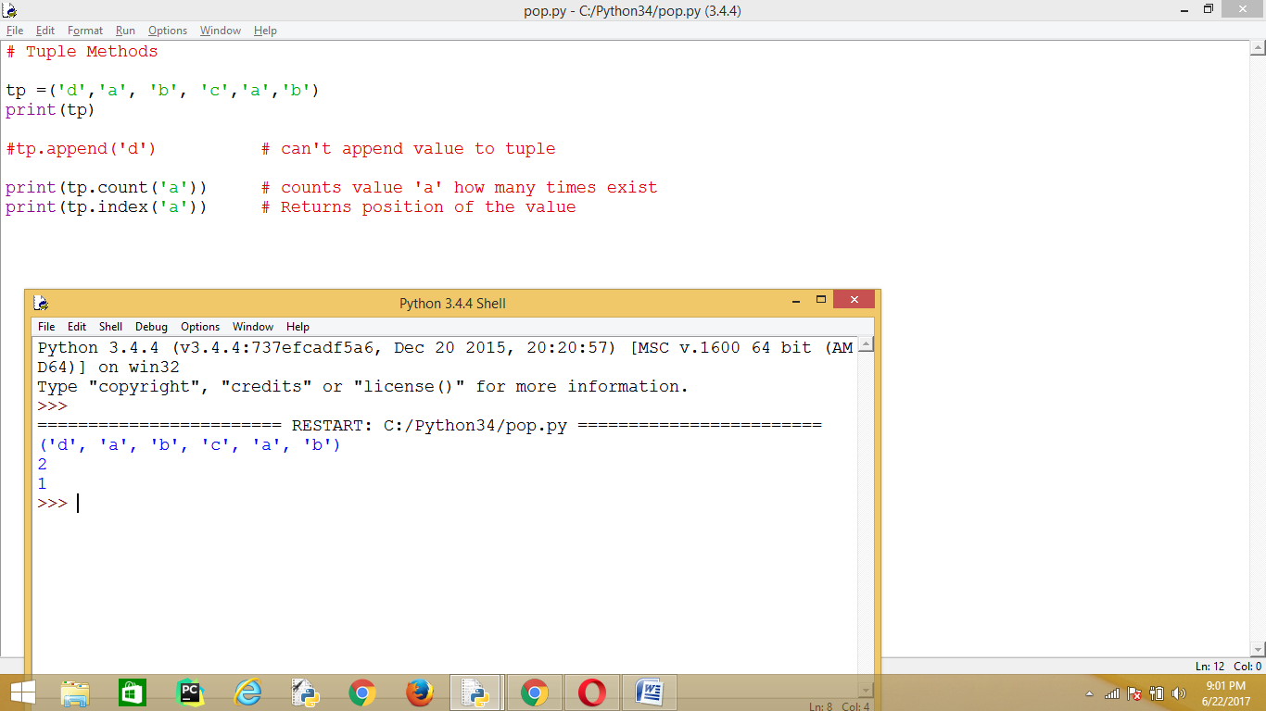

|  |  |  |
| --- | --- | --- |
| Python Expression | Results | Description |
| len((1, 2, 3)) | 3 | Length |
| (1, 2, 3) + (4, 5, 6) | (1, 2, 3, 4, 5, 6) | Concatenation |
| ('Hi!',) * 4 | ('Hi!', 'Hi!', 'Hi!', 'Hi!') | Repetition |
| 3 in (1, 2, 3) | True | Membership |
| for x in (1, 2, 3): print x, | 1 2 3 | Iteration |

**If any expression don’t have data type, default prints in TUPLE Type**

>>> print('abc', 123+456, 123)

abc 579 123

>>> print('abc', **123+456j,** 123)

abc (123+456j) 123

>>>

**Values not to change then place values in TUPLE Type**

Return type is list, can append new values

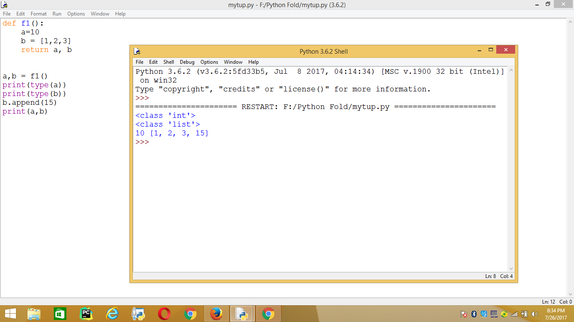

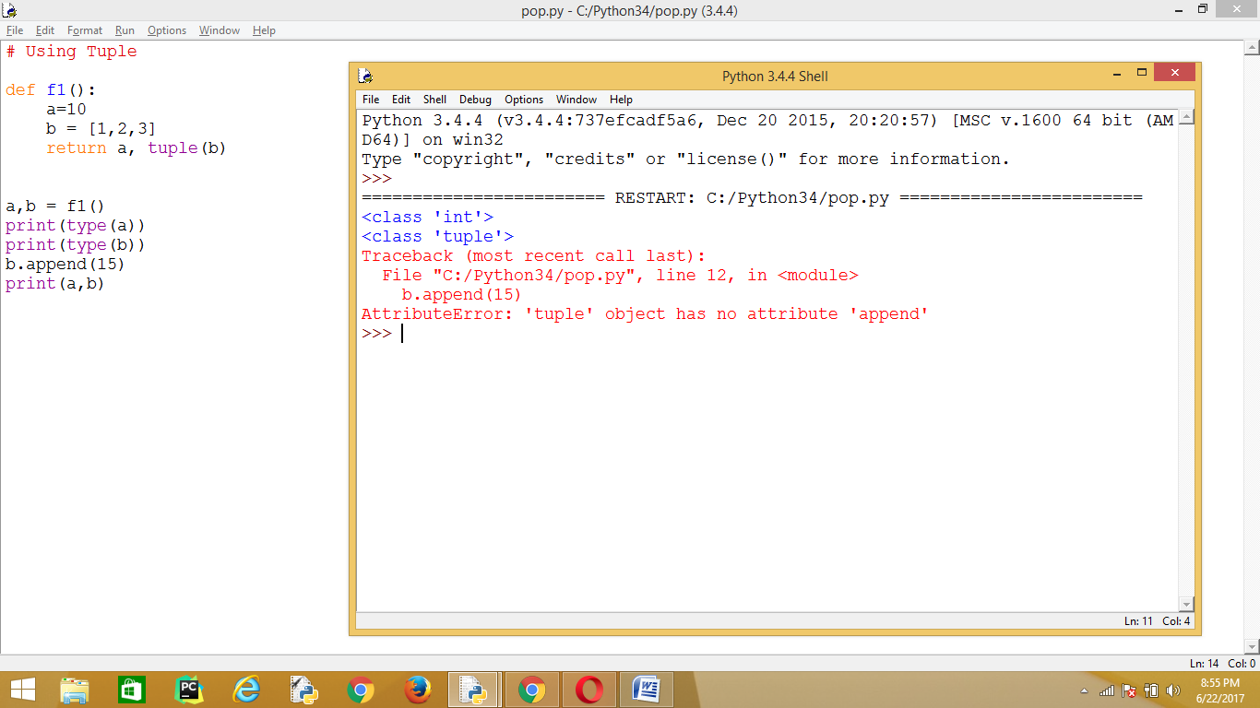

# Using Tuple

def f1():

a=10

b = [1,2,3]

return a, tuple(b)

a,b = f1()

print(type(a))

print(type(b))

b.append(15)

print(a,b)

*************************************************************************************************************************************************************************************************************************************************

***********************************************************************************************************************8

Set Union, Intersection , Set Difference

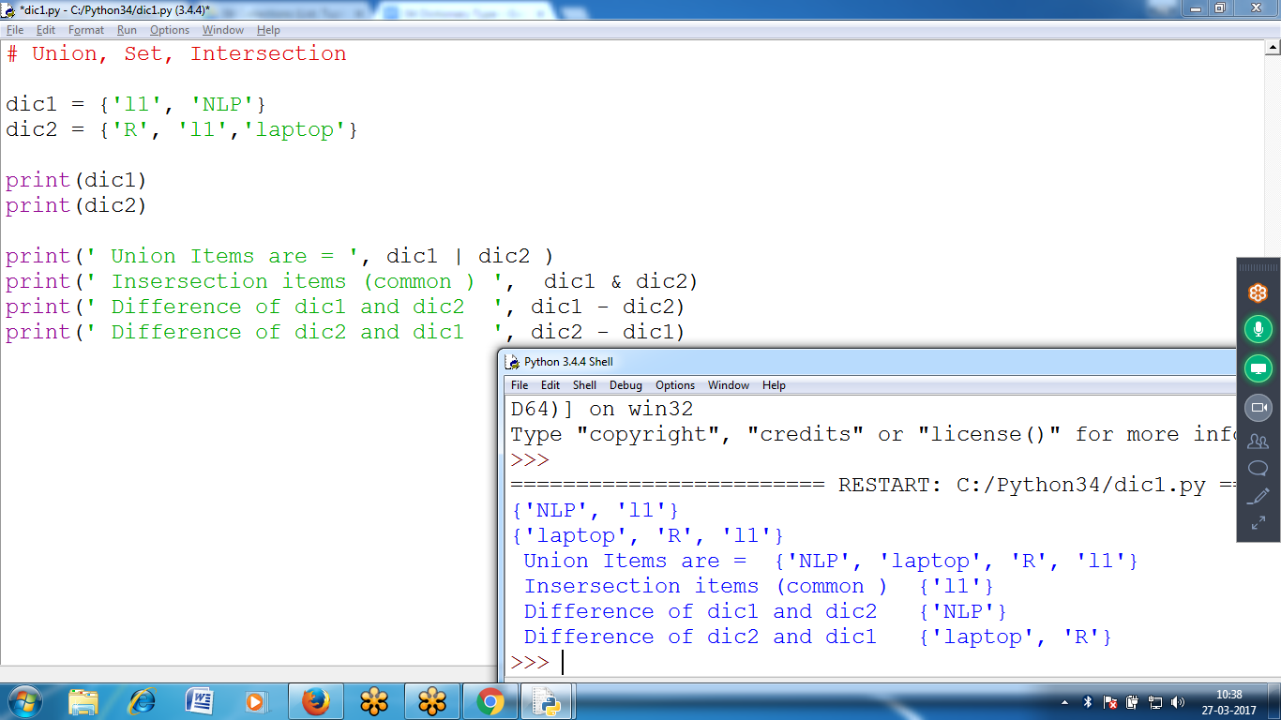

# Union, Set, Intersection

dic1 = {'l1', 'NLP'}

dic2 = {'R', 'l1','laptop'}

print(dic1)

print(dic2)

print(' Union Items are = ', dic1 | dic2 )

print(' Intersection items (common ) ', dic1 & dic2)

print(' Difference of dic1 and dic2 ', dic1 - dic2)

print(' Difference of dic2 and dic1 ', dic2 - dic1)

